

**Is Facebook Making You Depressed?**

**-How social media sites can cause the blues.**

**-Relationships**

**-Friends**

**-Pictures**

**-Hours wasted on**

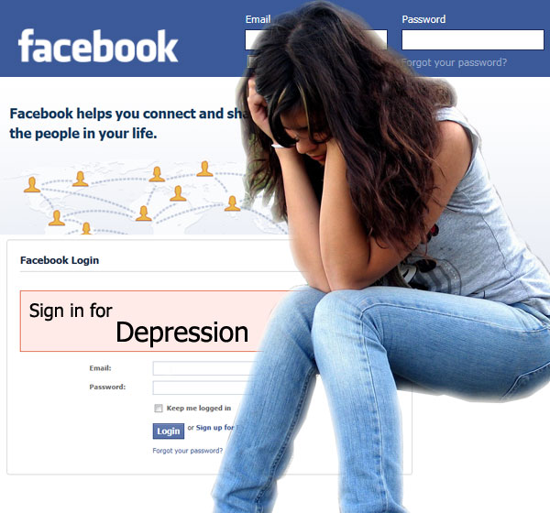

**Do you find yourself….**

-Comparing your pictures to others?

-Spending hours on Facebook?

-Feeling sad while on Facebook?

-Analyzing what others might think of your life?

**Join the cause to beat the blues!**

Come out to meetings

Every Monday night

9 pm in Room 320!